**GROUP MILESTONE- 3**

**PROJECT NAME:** PanVac Project

**GROUP NAME:** Group 1

**GROUP MEMBERS:** Sreejaya Parameswaran - SXP190110

Debshila Bhattacharya- DXB200002

Mariya Khalid -MXK153530

Lakshit Rajput- LXR190004

Prabhavi Soni - PXS190071

Meenal Badki - MHB180001

**Group 1: Analysis**

Contents

**Requirements**.........................................................................................................................................2

**Use Case Diagram**...................................................................................................................................5

**Class Diagram**..........................................................................................................................................9

**Sequence Diagram**................................................................................................................................10

**Minutes of Meeting**…............................................................................................................................11

1. **Requirements** 
   1. **Functional requirements**

5 types of Users - Super Admin, Admin, Hub Admin, Resident and MedTechnician

* + 1. **Resident**
       1. Registration

a) The proposed system will allow Residents to register for Covid19 Vaccination.

b) System will allow Residents to select preference over available vaccines such as Moderna, Pfizer or no preference at all. (Mandatory)

c) System will allow Residents to select a hub to get vaccinated.(Mandatory)

d)Residents can search and view all the available appointment dates, dates are visible only After selecting vaccine preference and center.

d) Once the date is selected, Residents can choose any available time slot to book the appointment. (Mandatory)

f) Residents can opt for notification of the registration by providing their phone number or email address. (Mandatory)

g) Residents are required to answer health related question (Mandatory)

h) Resident will provide answers on their job(Mandatory)

i) Residents will have to enter their Personal Details. (Mandatory)

j) On Successful Registration, Residents will receive confirmation details in their opted email or phone number. (Mandatory)

**Additional Notes**: ** Only Texas Residents will be able to Register for the Vaccine.

* + - 1. Pre-appointment declaration

a) Registration System will require Residents to fill a declaration form stating that they have not acquired or observed any Covid19 symptoms in the past two weeks. (Mandatory)

* + - 1. Vaccination Status

a) Vaccine status will be displayed at the site which includes the total number of people who had completed their vaccine doses in the city of Dallas.

* + 1. **SuperAdmin**
       1. SuperAdmin Dashboard

1. SuperAdmin user will have the rights to add Admin users and has the top user role.
   * 1. **Admin**
        1. Admin Dashboard
2. Admin user will have the rights to add Vaccine dose details ,Hubs and HubAdmin details.
3. Admin will allocate HubAdmins and Vaccine doses to each Hubs.
4. Admin will be able to view, edit and delete the added Hubs, Vaccine doses and HubAdmins.
   * 1. **HubAdmin**
        1. HubAdmin Dashboard
5. HubAdmin user will have the rights to Add Counters, MedTechnician and MedSupplies related to a hub.
6. HubAdmin will allocate MedTechnician, MedSupplies and Vaccine doses to different Counters in their Hub.
   * 1. **MedTechnician**
        1. Dashboard
7. MedTechnician will be able to view the appointments for the day at the hub.
8. MedTechnician will be able to check the appointment of the registered Resident.
9. MedTechnician will administer the vaccine to the registered Resident.
10. MedTechnician will update the vaccination status of the vaccinated Resident.
    1. **Non-functional requirements**
       1. **Performance**

The landing page of PANVAC supports 5 thousand users per hour with response time of 20 seconds or less in a web browser. PanVac offers swift response time.

* + 1. **Scalability**

In the case of our product PANVAC, the highest workload is 5 thousand users per hour without crashing the system.

* + 1. **Portability and Compatibility**

PANVAC can be accessed from mobile, tablet, laptop, and desktop web browsers. The minimum requirements are mentioned below:

Browser:

* Google Chrome 18.0.1025.108 and above
* Mozilla Firefox 17.0 and above
* Safari 3 and above

Hardware

* Quad core processor or better (recommended)
* Minimum 2GB RAM (recommended)

Operating System

* MAC
* Windows
* Android (for mobile/ tablet)
* IOS (for mobile/ tablet)
  + 1. **Reliability**

The product PANVAC has reliability of 97% for a month. It means that during a month, under normal usage conditions, there is a 97% chance that the system won’t experience critical failure.

* + 1. **Availability**

The product PANVAC has availability of 98% for a month including non-business hours CDT.

* + 1. **Maintainability**

Our product PANVAC will have a trained team, repair documents and planned maintenance to fix bugs and add new features efficiently so as to decrease the downtime.

* + 1. **Security**

In case of PANVAC, there is a defined login flow which ensures the protection from unauthorized access and data breach of personal information of users who are registering for the vaccine through PANVAC.

* + 1. **Localization**

Our product PANVAC comes with the below specification which ensures its success:

Language – English

Time-zone – CDT

Date format – mm/dd/yyyy

1. **Use Case Diagram**

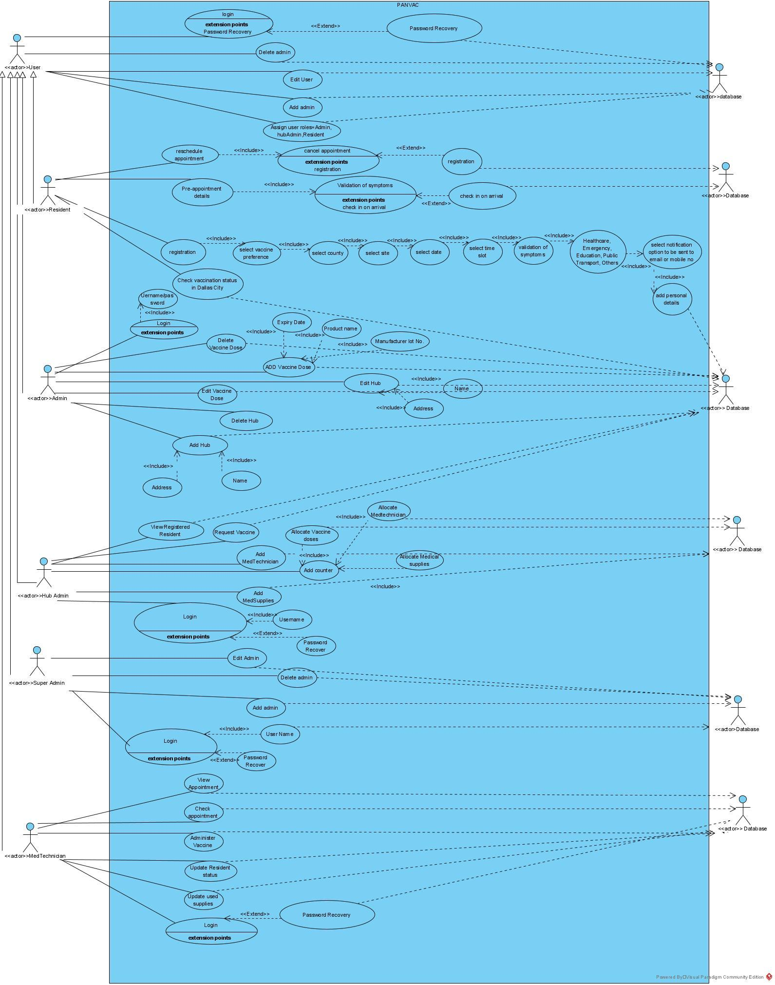

1. **Two Use Cases Description**

|  |  |
| --- | --- |
| Use Case Name: | Registration |
| Primary Actor: | User |
| Brief Description: | User enters site to register for the vaccine, where they can select the vaccine preference, select date, county, site, time slot, validate no symptoms, employer/field of work selection, add personal details, select notification option to be sent to email or mobile device |
| Trigger: | Resident wants to register for the vaccine and initiates booking |
| Normal flow of events: | 1. When the resident opens the vaccine registration site, they select the option to “register for the vaccine.” 2. Registration requires the following steps one after the another: 3. Resident selects vaccine type preference 4. Resident selects date 5. Resident selects county 6. Resident selects site 7. Resident selects time slot 8. Resident validates no presence of Covid-19 symptoms 9. Resident verifies field of work 10. Resident enters personal details 11. Resident selects notification preference to either be sent via email or to a mobile device |
| Alternate/Exception flow: | An exception to the normal flow is if the resident wants to register for the vaccine, but has symptoms in the last 14 days that makes him/her not eligible for the vaccine at that point in time. The registration process would then be aborted at that step and the system would need to notify the resident that they are not eligible for the vaccine, and thus the following are part of the exception flow of events:   1. Resident selects vaccine type preference 2. Resident selects date 3. Resident selects county 4. Resident selects site 5. Resident selects time slot 6. Resident selects that he/she had Covid-19 symptoms in the last 14 days 7. System prompts that they are not eligible for the vaccine at this time 8. Resident exits out of the registration portal |

|  |  |
| --- | --- |
| Use Case Name: | Login |
| Primary Actor: | Hub Admin |
| Brief Description: | Admin logs in with username and password to view the Admin dashboard, where he/she can add gloves, add facemasks, add syringes, add wipes, view registered customers, and allocate for counters |
| Trigger: | Hub Admin employee needs to update an item in the dashboard |
| Normal flow of events: | 1. When the Hub admin successfully logs in, he/she is redirected to the Hub admin Dashboard page.    1. Hub admin enters username.    2. Hub admin enters password.    3. Hub admin is prompted to and views the Hub admin dashboard. 2. Add Counter:    1. Hub Admin selects ‘Add Counter’.    2. Hub Admin adds details.    3. System executes request. 3. Add MedTechnician:    1. Hub Admin selects ‘Add MedTechnician’.    2. Hub Admin adds details.    3. System executes request. 4. Add Medical Supplies:    1. Add gloves:       1. Hub Admin selects ‘Add gloves’.       2. Hub Admin selects the number of gloves to be added.       3. System executes request.    2. Add facemasks:       1. Hub Admin selects ‘Add facemasks’.       2. Hub Admin selects the number of facemasks to be added.       3. System executes request.       4. Hub admin selects the number of facemasks to be added.       5. System executes request.    3. Add syringes:       1. Hub admin selects ‘Add syringes’ .       2. Hub admin selects the number of syringes to be added.       3. System executes request.    4. Add wipes :       1. Hub admin selects ‘Add wipes’.       2. Hub admin selects the number of wipes to be added.       3. System executes request.   5. View registered Residents   1. Hub admin selects ‘View registered Residents. 2. Hub admin selects date of registration. 3. System executes request.   6. Allocation for counter   1. Hub admin selects ‘Allocate for counter’. 2. Hub admin selects the Counter from the added counters. 3. Hub admin allocates Vaccine doses, MedTechnician and MedSupplies based on the registration for the day to each Counter. 4. System executes request. |
| Alternate/Exception flow: | An exception to the normal flow is when a Hub Admin looks for one of the options, but it is no longer available in the inventory of the site, in which case the system returns no results for that particular option. The following includes the steps in this exception flow of events:  When the Hub admin enters the PanVac site, they are prompted to a page with the option to login.  Admin selects the option to login.  Admin enters username.  Admin enters password.  Admin is prompted to and views the HubAdmin dashboard.  Admin selects ‘Allocate Vaccines to Counter’  System returns no vaccine to allocate to the Counter. |

1. **Class Diagram**

1. **Sequence Diagram**





1. **Minutes of Meeting**

Meeting 1:

|  |
| --- |
| Brief Description / Agenda |
| * Discuss on the Functional and Non-Functional Requirements of the proposed   System. |

|  |  |  |  |
| --- | --- | --- | --- |
| Meeting Date | 03/19/2021 | Meeting Location | MS TEAMS |
| Meeting Time | 5:00 PM | Meeting Title | Group Project Milestone-3 |
| Attendees | Meenal Badki; Debshila Bhattacharya; Sreejaya Parameswaran, Mariya Khalid; Prabhavi Soni and Lakshit Rajput | | |

Meeting 2:

|  |
| --- |
| Brief Description / Agenda |
| * Discuss on the Use cases and Class Diagrams |

|  |  |  |  |
| --- | --- | --- | --- |
| Meeting Date | 03/26/2021 | Meeting Location | MS TEAMS |
| Meeting Time | 5:00 PM | Meeting Title | Group Project Milestone-3 |
| Attendees | Meenal Badki; Debshila Bhattacharya; Sreejaya Parameswaran, Mariya Khalid; Prabhavi Soni and Lakshit Rajput | | |

Meeting 3:

|  |
| --- |
| Brief Description / Agenda |
| * Discuss on the Sequence Diagram |

|  |  |  |  |
| --- | --- | --- | --- |
| Meeting Date | 04/03/2021 | Meeting Location | MS TEAMS |
| Meeting Time | 5:00 PM | Meeting Title | Group Project Milestone-3 |
| Attendees | Meenal Badki; Debshila Bhattacharya; Sreejaya Parameswaran, Mariya Khalid; Prabhavi Soni and Lakshit Rajput | | |

Meeting 4:

|  |
| --- |
| Brief Description / Agenda |
| * Review tasks and Corrections |

|  |  |  |  |
| --- | --- | --- | --- |
| Meeting Date | 04/11/2021 | Meeting Location | MS TEAMS |
| Meeting Time | 5:00 PM | Meeting Title | Group Project Milestone-3 |
| Attendees | Meenal Badki; Debshila Bhattacharya; Sreejaya Parameswaran, Mariya Khalid; Prabhavi Soni and Lakshit Rajput | | |